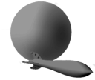
New World Industries Inc.

Set-up and Operation

CA-100-1B Proportional Valve Controller

Physical Connections:
The CA-100-1 Proportional Valve Controller provides control for a single proportional valve solenoid. The connections to the CA-100-1 are outlined in Figure 1. The splash screen will show 1A/B and configuration menu should be set using 1A/B but will apply only to coil 1A because the CA-100-1 is a single coil Valve Driver.

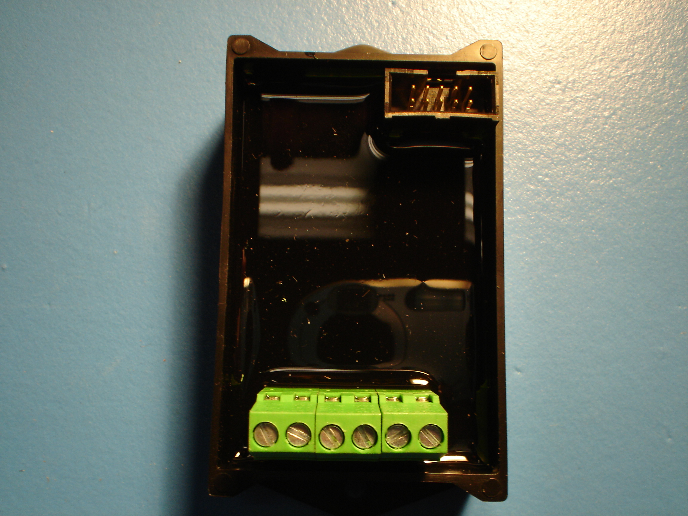
RS232
PORT
#6, 4-20mA
COMMAND
INPUT
#1, PWM OUT

#2, POWER

#3, COMMON
#5, 0-5VDC
OR
0-10 VDC
COMMAND INPUT

#4, 4.8VDC
SUPPLY @ 50mA MAX

Fig. 1 Physical connections to the CA-100 Valve Controller

User Configuration:
The CA-100 is software configurable via a standard PC or Laptop using Hyperterminal, any serial communication software or the NWI PA-100 programming adapter. The configuration menu is in the controller and does not need additional program installation on a computer.

Communication:
Communicating to the CA-100 controller is by means of a serial RS232 connection (generally COM1 or COM2 on a PC) using NWI’s PA-100. The CA-100 uses an industry standard DB-9 connector.

The serial communication parameters are as follows:
- Baud Rate (bits per second): 115200.
- Data Bits: 8
- Stop Bits: 1
- Parity: None
- Flow Control: Xon/Xoff

When first connecting to the controller the “Splash Scan” screen will appear.
New World Ind., http://www.nwi-online.com
CA-100 thru CA-102 series proportional valve controller
PICos18_v3.00;Mar 09 2008

V-TSK:READY
D-TSK:STOP
ERR: 0x 0
Coil 1A/B
RANGE: 0-5 VDC
CMD INPUT: 0 ENABLE: Y
CMD CURRENT: 0 mA PWM OUTPUT: 0 ticks
CMD OUTPUT: 0 mA ACT OUTPUT: 0 mA
DITHER ENABLE: N
Coil 2A/B
RANGE: 0-5 VDC
CMD INPUT: 0 ENABLE: Y
CMD CURRENT: 0 PWM OUTPUT: 0 ticks
CMD OUTPUT: 0 mA ACT OUTPUT: 0 mA
DITHER ENABLE: N
Press <e> to enter configuration

Fig 2 Typical HyperTerminal menu screen showing Splash Scan

This screen is used to check controller status and for error codes.
- V-TSK indicates VALVE TASKS are either READY or STOPPED
- D-TSK indicates DITHER TASKS are either READY or STOPPED
- ERR is a self-generated error code for diagnostic purposes.
The remainder of the screen shows Valve coil status for Inputs and Outputs.

Press <e> to enter configuration

Configuration Setup and Status:
1A CONFIGURATION

<key>: Increase / Decrease / Modify Settings
<i> : Input range :0-5VDC
<2,3>: +/- Minimum Current : 0 mA
<4,5>: +/- Maximum Current : 0 mA
<6,7>: +/- Zero Setpoint : 0% of Input range
<8,9>: +/- Zero Deadband : 0% of Input range
<F,f>: +/- Dither Freq: 0 Hz
<A,a>: +/- Dither Amplitude: 0%
<U,u>: +/- Up-Ramp seconds: 0 mS
<D,d>: +/- Dn-Ramp seconds: 0 mS
<C,c>: +/- Rated coil current @ rated voltage: 0 mA

Press <e> to enter configuration

Fig. 3 Typical HyperTerminal menu screen showing default values

Shown in Fig. 3 is a typical HyperTerminal menu screen showing the default values. A description of each configuration item is as follows:

- Input Range: There are 3 possible settings. Choose which input type by pressing the letter “i” and the 3 selections will scroll thru. 0-5VDC, 0-10VDC or 4-20mA can be selected. Default set to 0-5VDC. When using the on-board (terminal #4) 4.8 VDC power supply as a control input source a jumper wire (can also be used as a switched valve enable wire) must be installed between terminal #4 and #6 with the command voltage connected to terminal #5. When using current as an command input, a jumper must be installed between terminal #4 and #5 with the command current supply connected to terminal #6
- Minimum Current: This setting is the minimum PWM output required for correct valve operation to the A coil. Press either 2 or 3 to increase or decrease this setting. Default set to 0
- Maximum Current: This setting is the maximum PWM output required for correct valve operation to the A coil. Press either 4 or 5 to increase or decrease this setting. Default set to 0 mA
- Zero Setpoint: This variable is used to scale either up or down by percentages of the selected Input Range where the PWM signal starts from. This setting is usually determined by the command input device that’s being used. Because the CA-100 is a single coil driver the default set to 0 and is non-adjustable.
- Zero Deadband: This is the percentage of the selected Input Range based on the Zero Setpoint and Maximum Current setting that allows an input voltage deadband when tuning the input device to the controller. Press either 8 or 9 to increase or decrease this setting. Default set to 0
- Dither Frequincy: The Dither Frequency is software adjustable from 0 to 250 hz. Press F or f to increase or decrease the dither frequency. Default set to 0

- Dither Amplitude: The Dither Amplitude is software adjustable from 0 to 10% of the duty cycle. Press A or a to increase or decrease the dither amplitude. Default set to 0
- Up Ramp: This enables a preset ramp up time in mS. How the ramping up works is, once a value is entered, this is based on a full voltage command signal. An example would be, if the controller is set to run on 0-10VDC and ramping is set to 3000mS, if the full 10VDC command signal is given from a 0VDC start, there will be 3 seconds of ramping.
- Down Ramp: This enables a preset ramp down time in mS. How ramping down works is the exact opposite of ramping up. Example would be, when the command voltage is pulled down to 0 from the maximum command voltage, the controller will ramp down in the time determined by the preset valve entered.
- Rated coil current @ rated voltage: This setting should be determined by the valve manufacturers maximum coil rating and set accordingly to insure full operation of the valve coil. Default is 0mA

Saving Settings: After configuring the selected solenoid/coils, exit the set-up screen using the “N” key to save it to the microprocessor. The controller will retain this configuration until repeating the above process changes the values.

COPYRIGHT, NEW WORLD INDUSTRIES INC. 2008

